Uploading Facebook Blurb and Picture to Presspoint
These are the steps to upload the Facebook blur and pictures to Presspoint:
- Login to Presspoint using the link, username, and password provided.  - Once logged in, hover the cursor on Presspoint then click on Reports. | 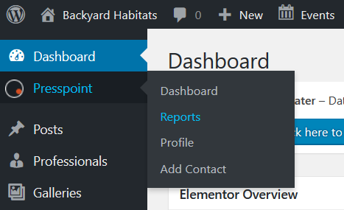  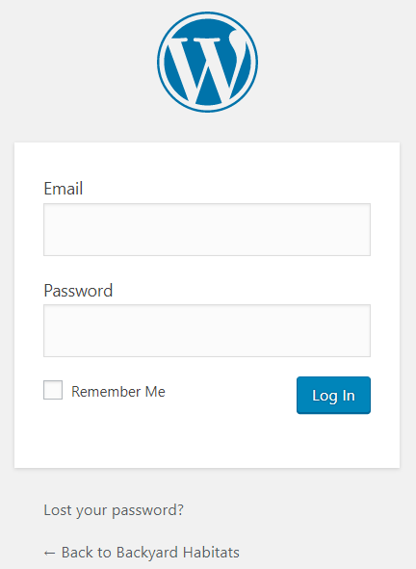
- Once in the reports area, choose Site Address “Like”.  The following 4 field searches will appear.  - Copy the address number from the email form and paste it into the “Address Line One” field.  The reason why you only copy the numbers is because sometimes the volunteers leave out or misspell parts of the full address. If you write “Street” instead of “St”, the system will not show what you are looking for, for example.  - Find the property that you are looking for in the results area, and click on View.  NOTE: The new Presspoint separates properties (building avatar) and individuals (person avatar) into different profiles. In the example to the right, you can see both profiles for the same address.  NOTE 2: If you are unable to find the person you are looking for using the Address Line One field, change it from “Like” to “Show”, then change the Last Name field from “Show” to “Like” and type the person’s last name. | 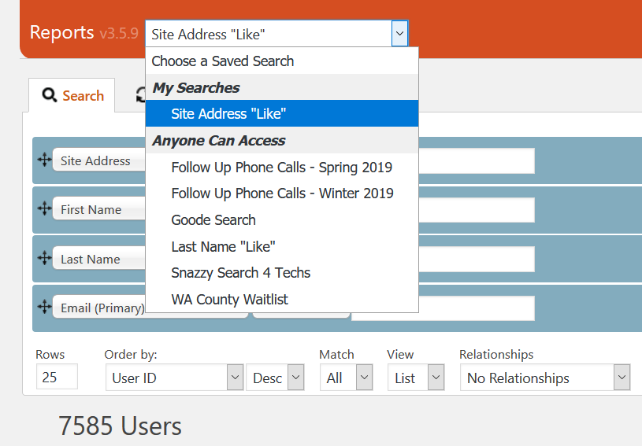  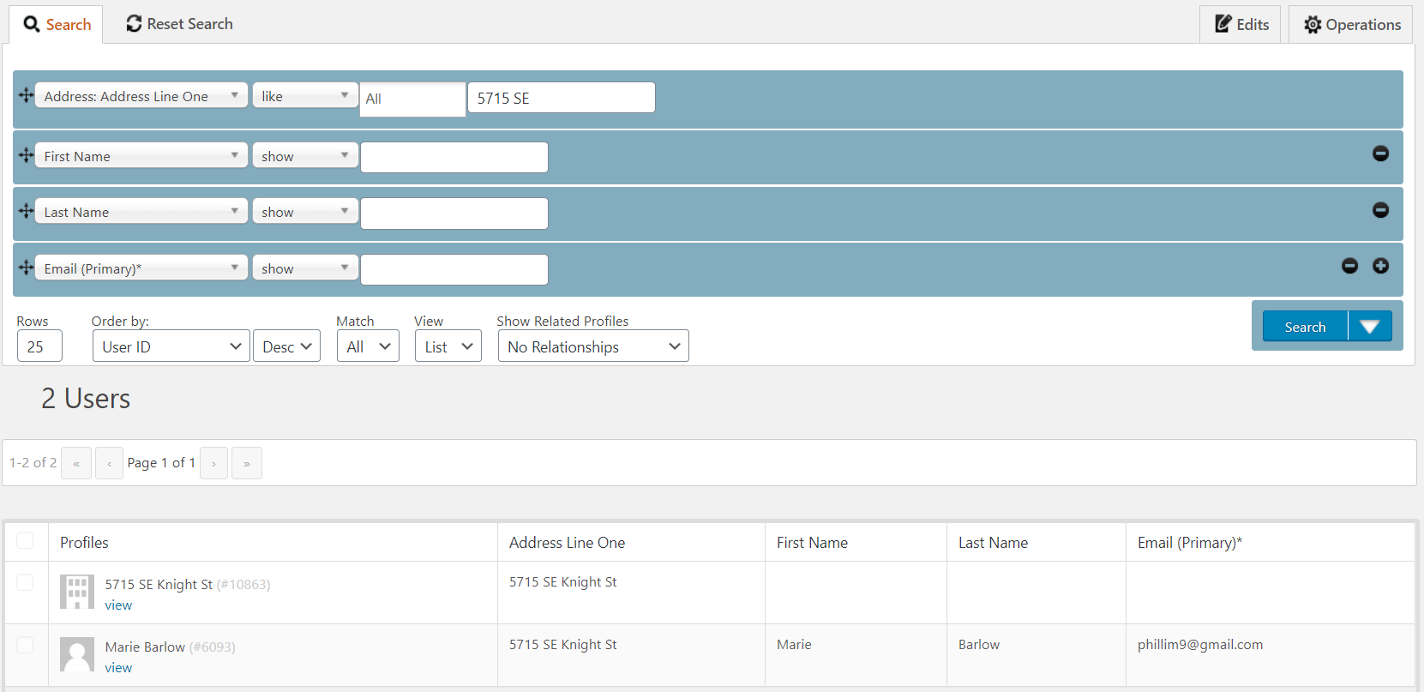
In the Individual Profile page:  - Click the Actions button and select Note.  - In the screen that opens, complete the fields:  Subject: for certification visits, the subject should be “Cert Visit Note”.  Date: type or select the date of the certification visit.  Message: Type the Facebook text in this box.  This is the blurb guideline:  - Start the post by sharing the participant(s) first name and the city or neighborhood where the property is located. Tell us your good impressions about your visit, and work in special details about and the features of the yard. Tell us about the participants(s)' accomplishments (what changed since enrolling in the program? Was this a blank canvas or an ivy patch? Etc.).  - Next, name a few of the native plants that you saw at the property. Bonus points for adding how those native plants are being used (hedgerow, raingarden, etc.).  - Lastly, celebrate the participant's accomplishments making sure to mention the certification level achieved.  Type of Interaction: single click the down arrow inside the selection box and select “In-Person Conversation.”  - Click the “Save” button. | 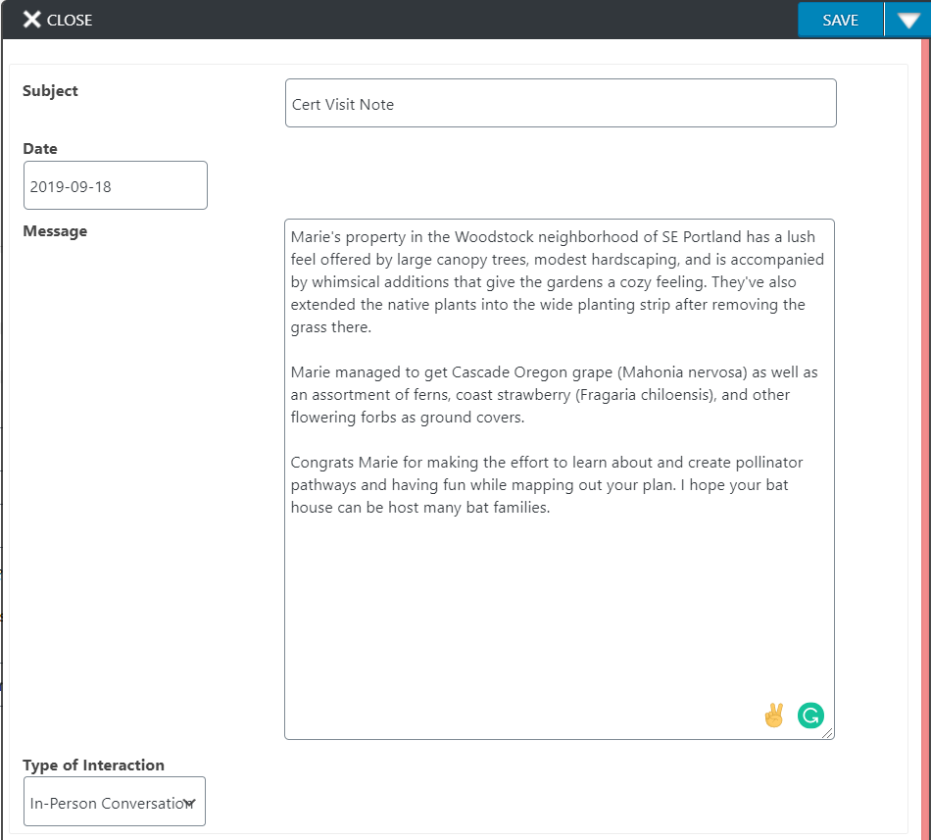  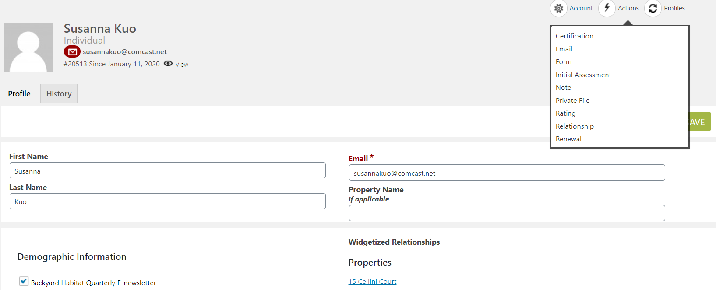
Uploading the certification picture  - Start with the file name for the picture that you saved in your computer, make sure that it follows the LastNameFirstInitial_CertLevel_Date format  Example: HoweR_GoldCert_11-07-2017  NOTE: Do not use a comma between last name and first initial.  - In the Individual Profile, click on the “Empty Picture” Avatar. A panel will open on the right side.  - Click the Choose File button to select the picture file saved in your computer.  - Copy the file name and paste it in the Title field. Remove the extension from the file name (Ex: .jpg, .png, etc.)  - Enter the certification date in the Date field.  - Leave the Notes field blank.  - Click the Save button.  NOTE: In the case you added the picture as a single file instead of as a profile picture, all you have to do is:  - open the file in the History tab.  - check the box that says “Make this my profile image.”  - click the save button. | 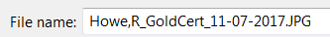  No comma!  