DATA ENTRY FOR INITIAL VISITS
These are the steps to process an initial site visit data:
- Login to Presspoint using the link, username, and password provided. This will take you to your dashboard. | 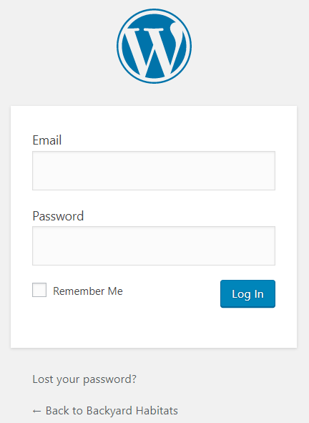  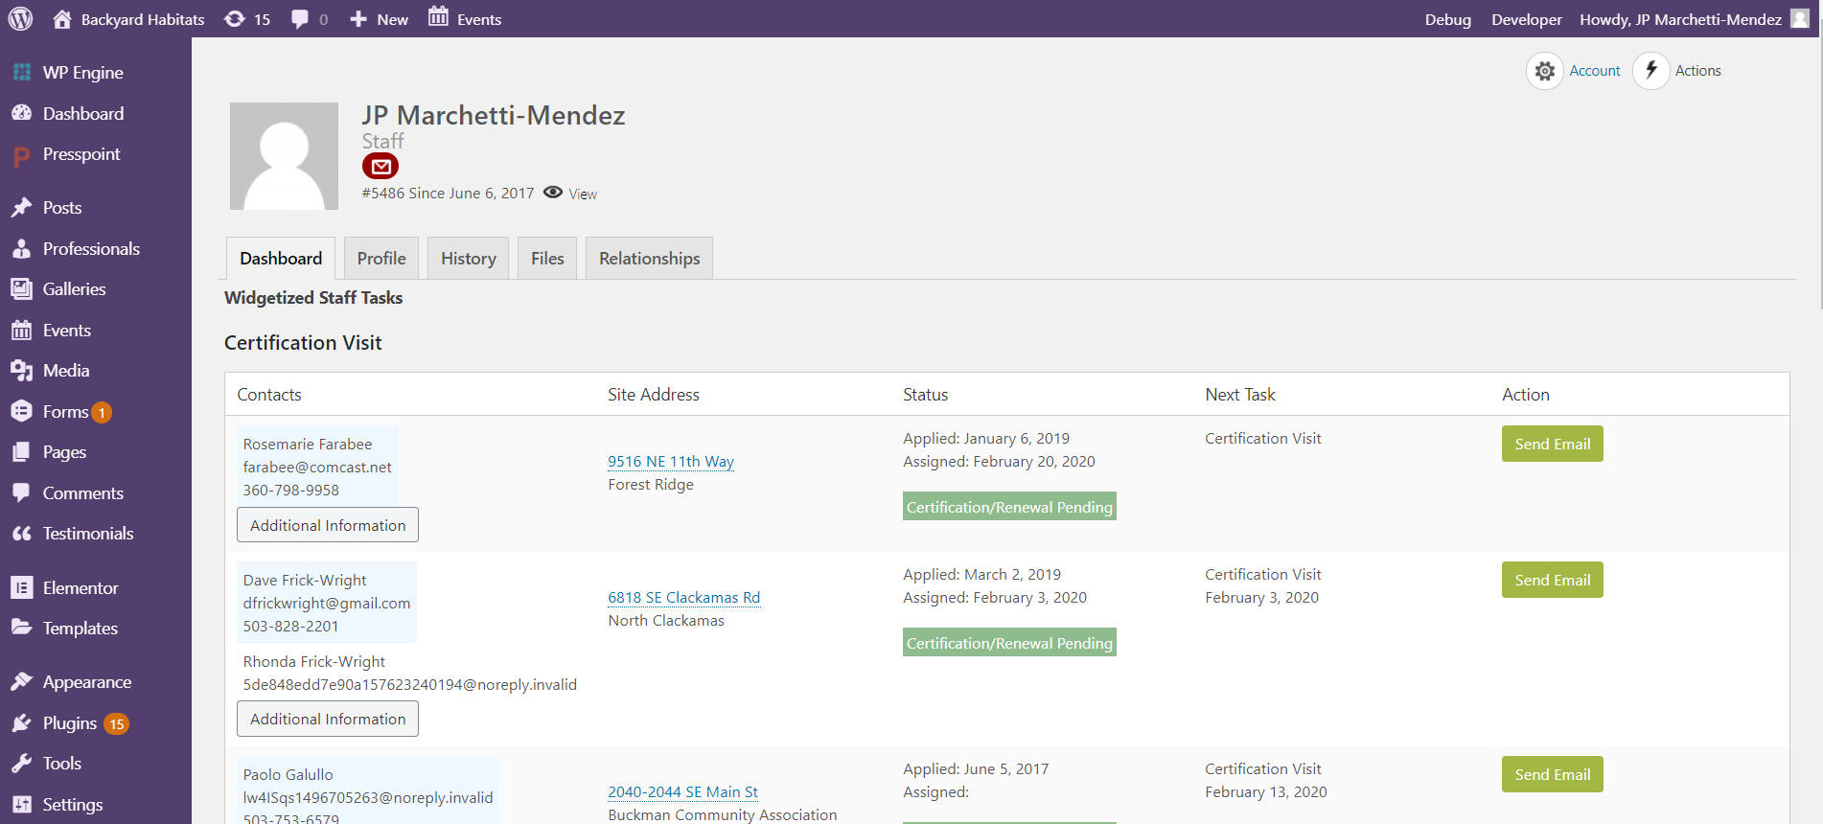
- Find the property that you are looking for in the dashboard, and click on the site address hyperlink.

In the Property Profile page:  - Check that the city, state, postal code, neighborhood, and county fields are not blank or misspelled.  NOTE: In case any errors are found, please alert Rachael with the property hyperlink. Do not correct the data yourself.  - Change Site Status to In Progress.  - Select the Property Type field.  - Change the Next Task to Follow Up Phone Call.  - In the Task Date field, pick a date 6 months ahead.  - Keep your name in the Next Task Assigned field.  - Click the Save button.  - Click the Actions button (top right corner) and select Initial Assessment. | 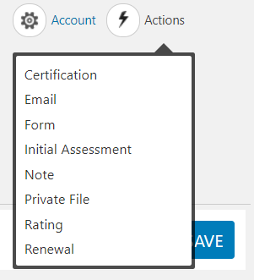  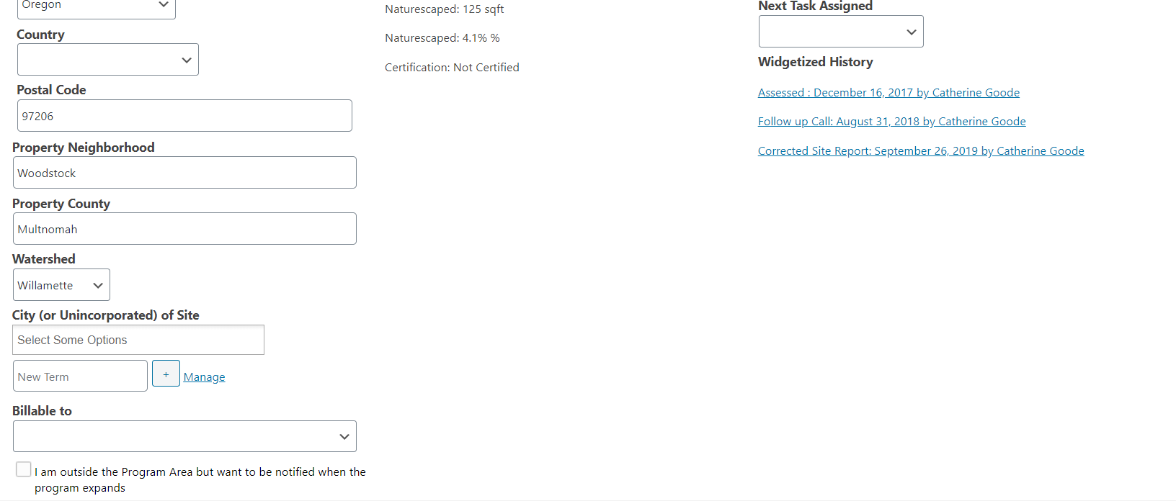  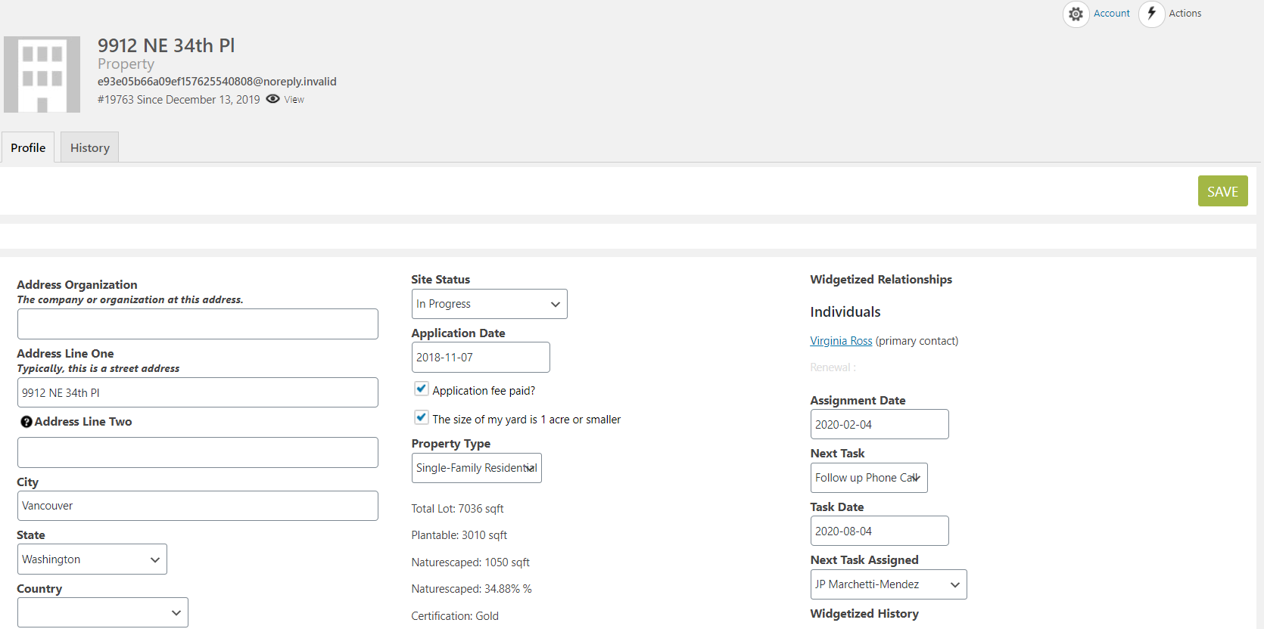
- In the panel that opens on the right, enter the data of the paper site visit form into the appropriate fields, including:  - Assessment Date  - Technician  - Certification Level (In Progress or Certification Level)  - Watershed  - Onsite Natural Water Source (if applicable)  - Lake Oswego Demo Site (if applicable)  - Total Lot Size  - SQ FT plantable area  - SQ FT Naturescaped  NOTE: % Naturescaped is auto-calculated.  - All remaining fields in the Assessment Base Data area.  NOTE2: NEVER use “N/A” or “none” for blank fields. Simply leave them blank.  NOTE 3: NEVER use the blank field or Manage hyperlink to add a new term to the choices.  - Click the Save button. | 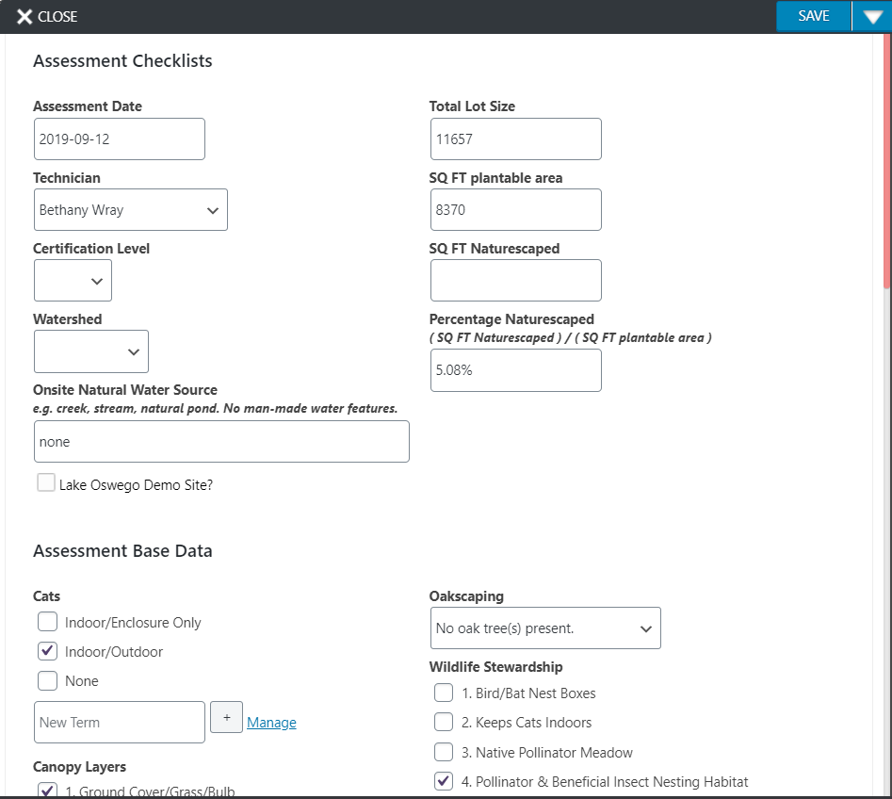
NOTE: You can easily edit an Initial Assessment Form by clicking the “Assessed” hyperlink in the widgetized history of the property profile, or by going to the History tab and clicking on the Initial Assessment hyperlink.  NOTE 2: NEVER use the Actions > Initial Assessment button to edit an initial assessment. Doing so will create a new site assessment form instead. | 