DATA ENTRY FOR TECHNICIAN CERTIFICATIONS
These are the steps to process the data of an initial site visit turned certification:
- Login to Presspoint using the link, username, and password provided.  This will take you to your dashboard.  What your dashboard will look like:  - Find the property that you are looking for in the dashboard area, and click on the property address’ hyperlink. |  | 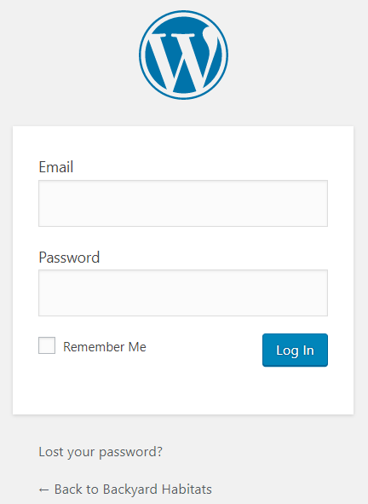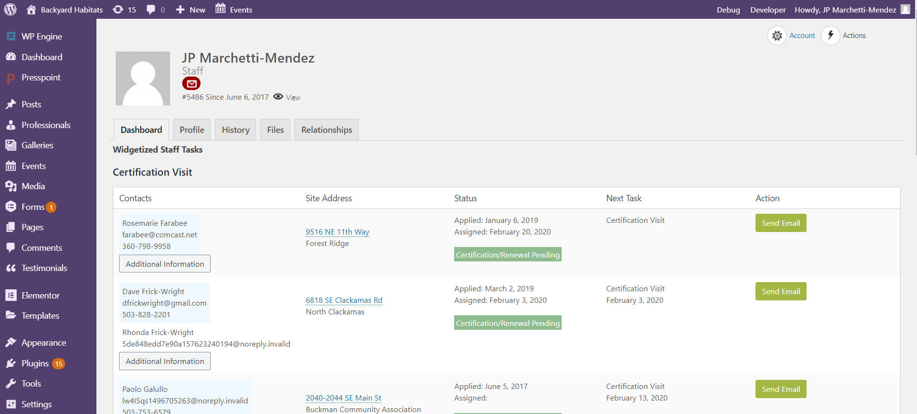  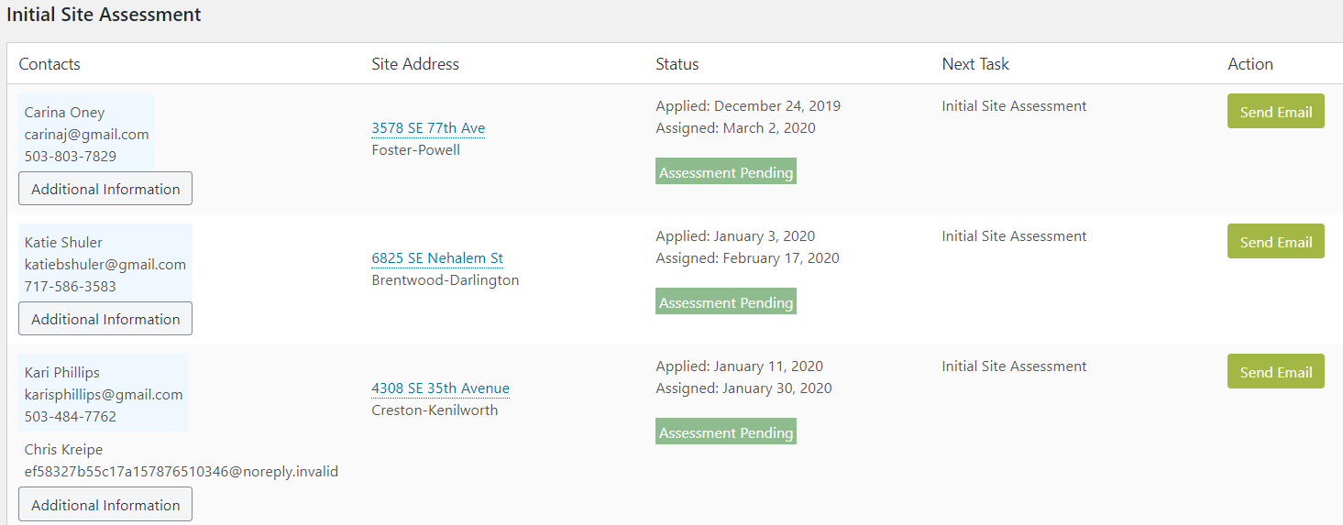
 | In the Property Profile:  - Check that the city, state, postal code, neighborhood, and county fields are not blank or misspelled.  - Select the Watershed and Property Type.  - Change Site Status to Certified.  - Change the Next Task to Renewal.  - Change the Task Date to 3 years in the future.  - Make the Next Task Assigned fields blank.  - Click the Save button.  NOTE: If you find out during the site visit that the site is a business or organization, enter the name of the organization into the “Address Organization” field. | 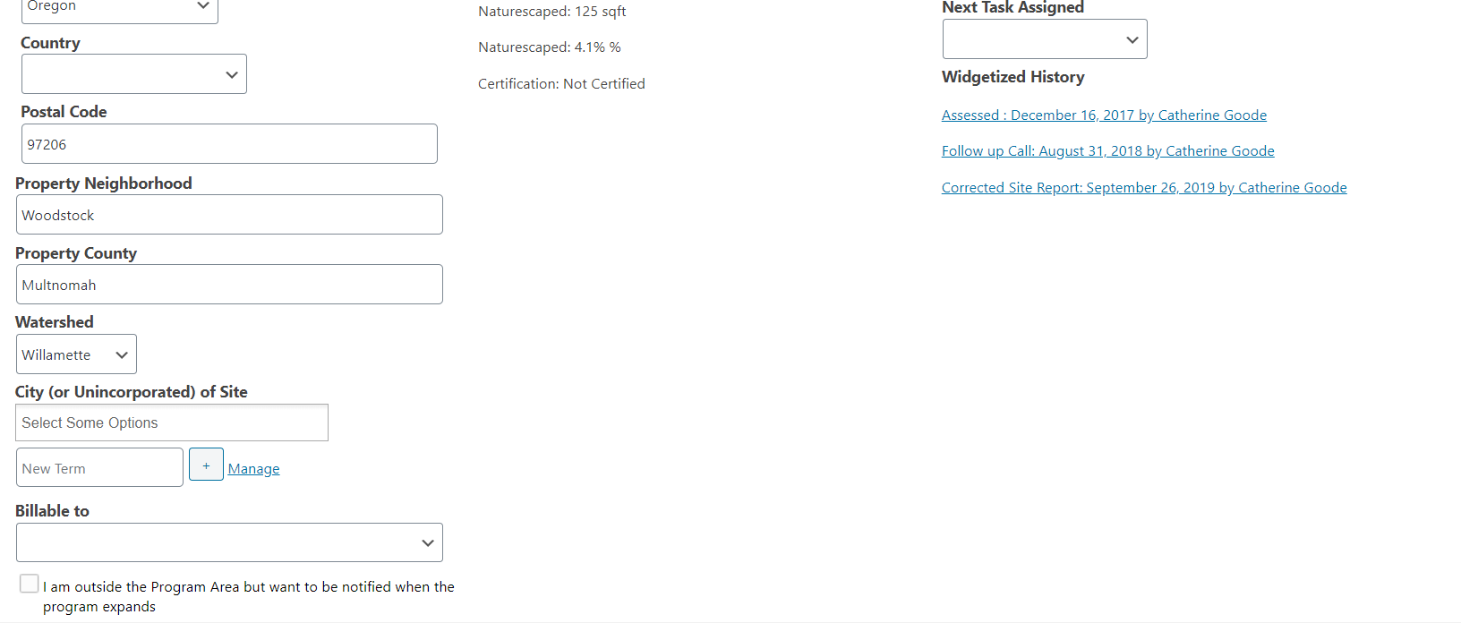  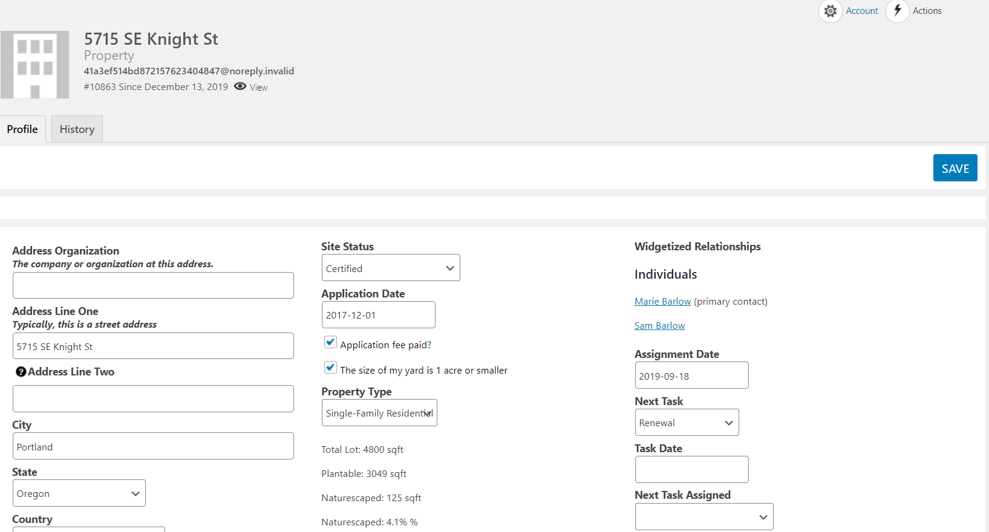
 | NOTE: If you haven’t entered the initial visit data, follow the instructions in the Data Entry for Initial Visits training guide before proceeding to the next steps.  - Click the Actions button (top right corner) and select Certification. | 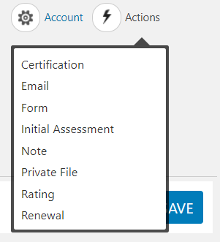
 | - In the panel that opens on the right, enter the data from the site visit:  - Certification Date  - Certification Performed By (your name)  - Certification Level achieved  - SQ FT Naturescaped  - Percentage Naturescaped  - Native Trees Planted  - Native Shrubs & Groundcovers Planted  - ALL remaining fields in the form (if applicable).  - Check Outstanding Example if the yard was yard tour worthy.  NOTE: NEVER check the boxes under the Certification Level field.  NOTE 2: NEVER use the blank field or Manage hyperlink to add a new term to the choices.  - Click the Save button.  NOTE: You can easily edit the Certification Form by going to the History tab of the Property profile and clicking on the Certification hyperlink. You will be back at step 13.  - Upload a photo and their “Facebook blurb” by following the steps on the Uploading Facebook Picture and Text to PressPoint manual. | 