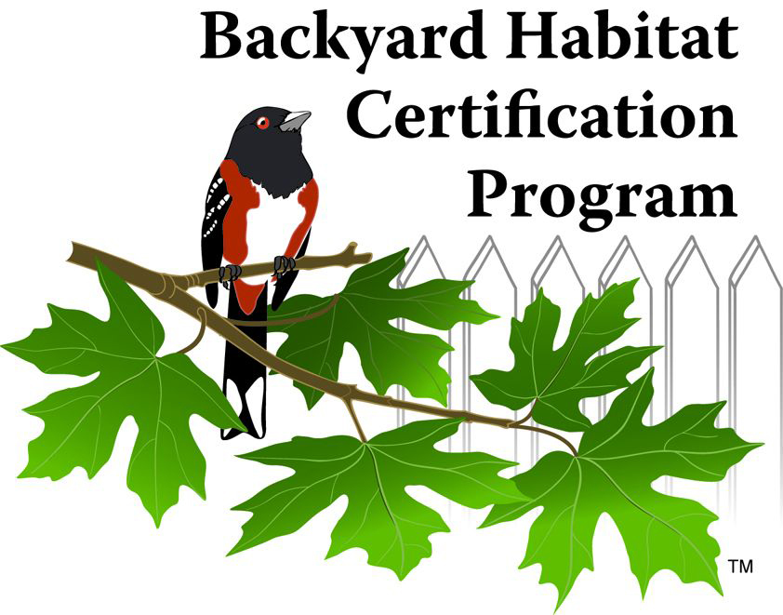
Native Plants Tracking Sheet

Tracking the plants you’ve planted as you create habitat in your outdoor space is fun! It also helps you remember what plants have thrived in your yard’s growing conditions. As you move through the program, we’ll be asking you to share how many plants you’ve planted along the way, which we use to measure the program’s positive impact on the region’s biodiversity and ecosystem health. Thank you for helping us track this important information!
Canopy Layers: In identifying naturescaped areas, we look for the presence of multiple canopy layers, which help create a dynamic habitat. Different canopy layers provide different benefits (i.e., food, shelter, nesting, etc) to birds and other wildlife. The 5 canopy layers we reference in the program are Large Tree, Small Tree, Large Shrub, Small Shrub/Fern/Grass, and Ground Cover.
Native plant species | # of Plants | Canopy layer
Example: Western red cedar | Example: 7 | Example: Large tree

Thank you for tracking the native plants you’ve planted! More tracking sheets are available in the Resource Library here: backyardhabitats.org/site-report-resource-library

