READY FOR CERTIFICATION VISIT
These are the steps to connect participants ready to get certified and volunteers:
- Login to Presspoint using the link, username, and password provided.  - Once logged in, hover the cursor on Presspoint then click on Reports. | 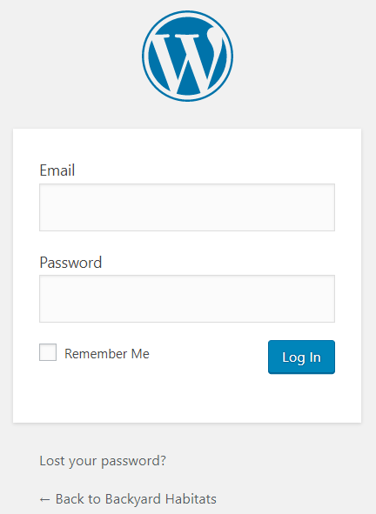  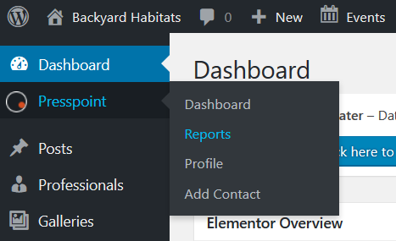
- Once in the reports area, choose Site Address “Like.”  The following four field searches will appear.  - Use “like” in one of the four fields, followed by the information that would most likely find the person that you are searching for.  Example: The street address is like 5715 SE.  - Find the property that you are looking for in the results area, and click on View.  NOTE: The new Presspoint separates properties (building avatar) and individuals (person avatar) into different profiles. In the example to the right, you can see both profiles for the same address.  NOTE 2: If you are unable to find the person you are looking for using the Address Line One field, change it from “Like” to “Show,” then change the Last Name field from “Show” to “Like” and type the person’s last name. | 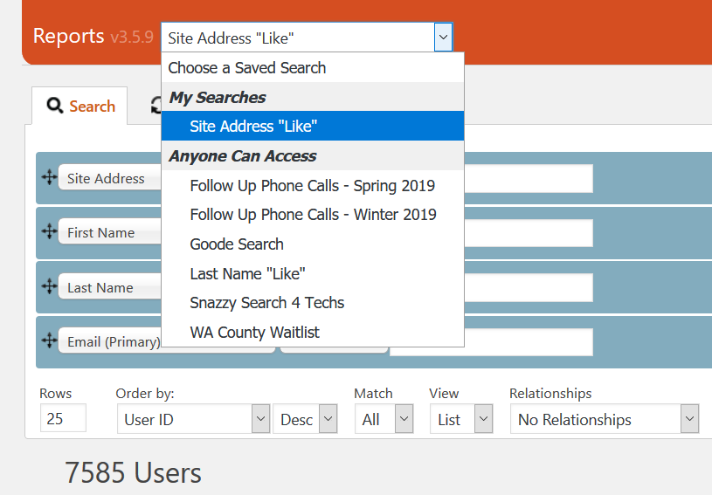  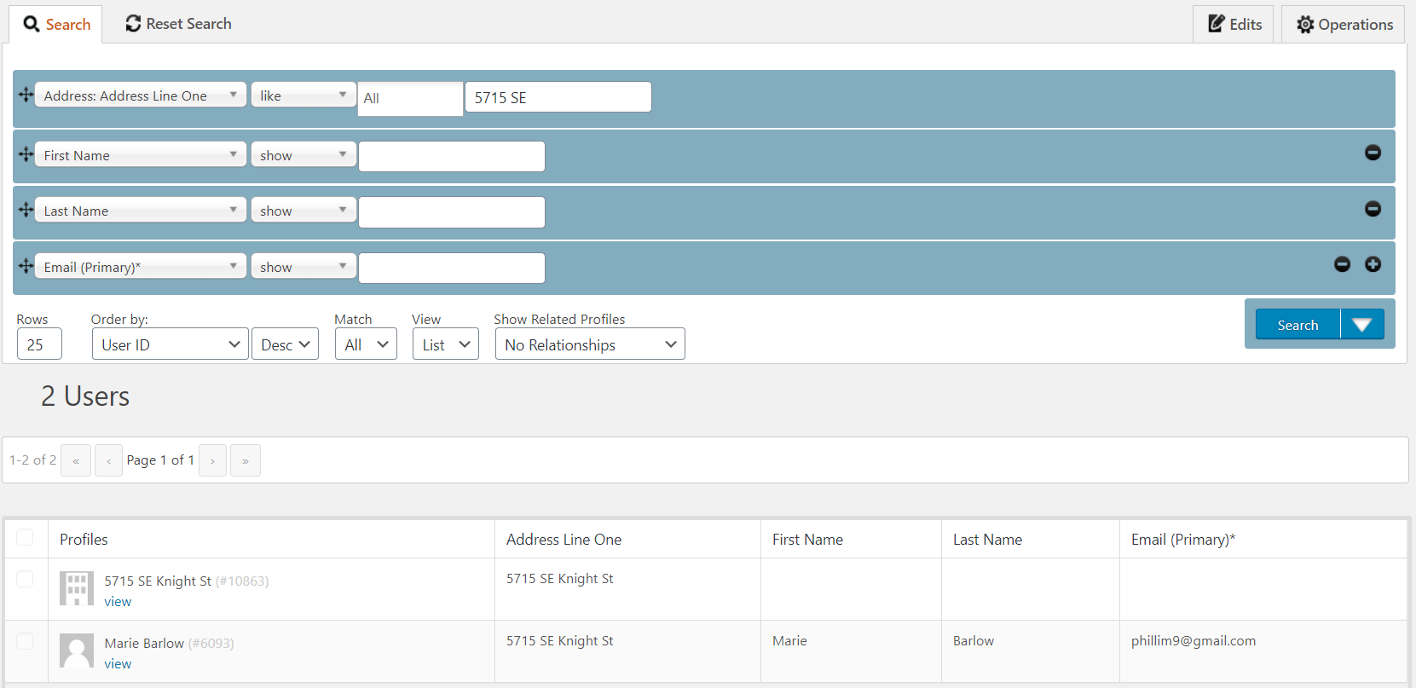
In the Property Profile page:  - Change Site Status to Certification/Renewal Pending.  - Change the Assignment Date field to the day you spoke with the participant.  - Change the Next Task to Certification Visit (for In Progress properties) or Upgrade Visit (for Certified or Inactive properties).  - The Task Date field should be blank.  - Select JP Marchetti-Mendez for the Next Task Assigned.  - Click the Save button.  NOTE: Upon changing the Next Task Assigned field, the property will move from the person in that field’s dashboard to the dashboard of the person being added to that field. | 