WESTERN RED CEDAR / INCENSE CEDAR / ALASKA CEDAR
Thuja plicata  Western Red Cedar | Calocedrus decurrens  Incense cedar | Callitropsis nootkatensis  (aka Cupressus nootkatensis)  Alaska Cedar  aka Alaskan Yellow Cedar
PPL List: large tree | PNW Native: large tree | PNW Native: large tree
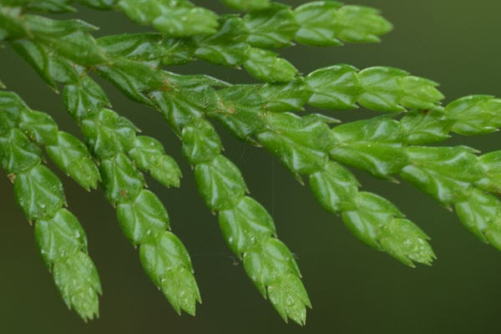  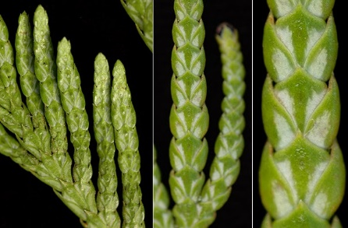  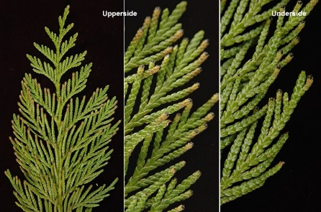 | 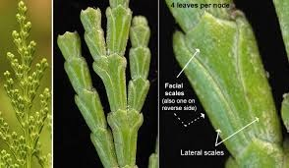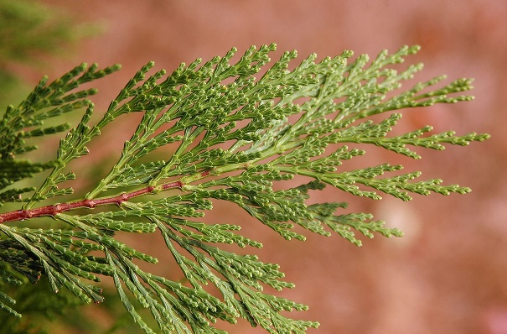 | 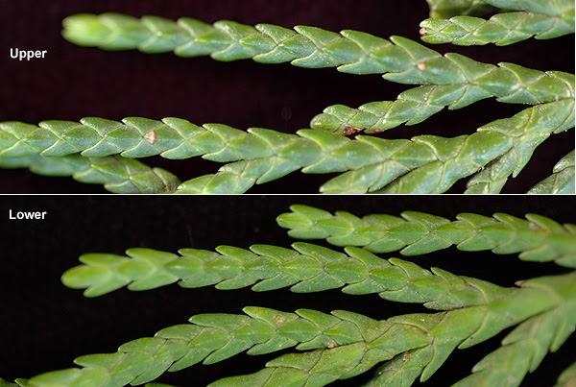  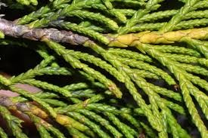
Flat, wide, scale-like leaves,  often have butterfly or moth-like pattern on underside | Small, flat, scale-like leaves, often described as akin gto wine glass or champagne flutes | Scaled with pointed tips (can be prickly) & no white pattern on underside
Branches horizontal or drooping but turning upward at the end; narrow, pyramidal form | Narrowly columnar, terminating in flattened branchlets with dense, fan-like sprays | Unlike other false cedars, has distinctive drooping branchlets
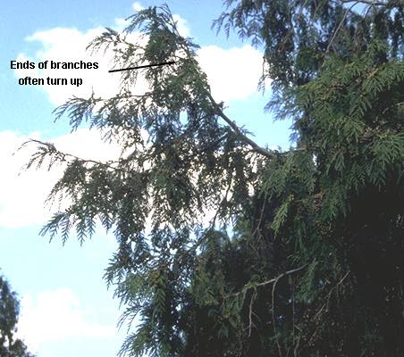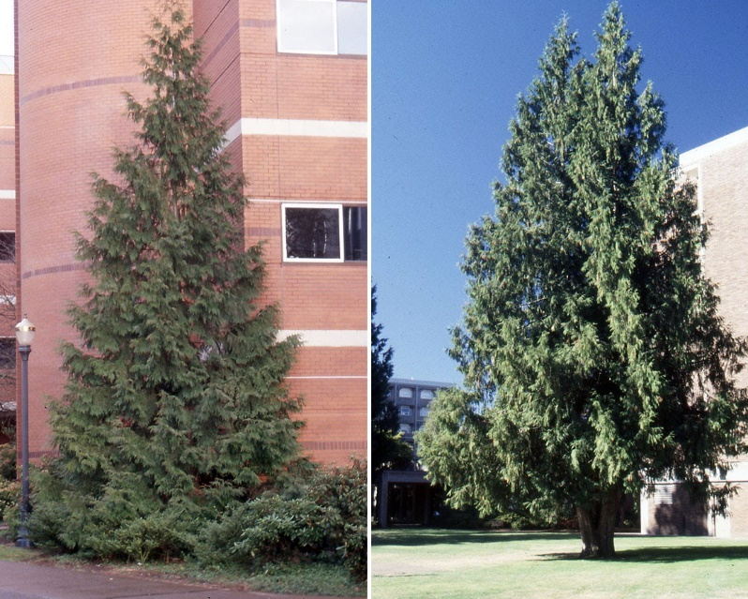 | 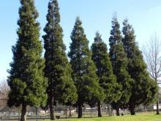  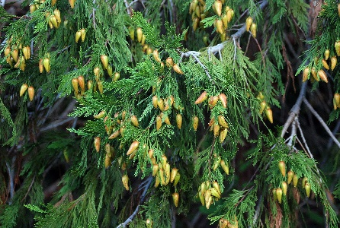 | 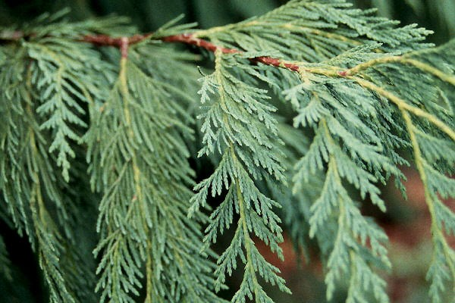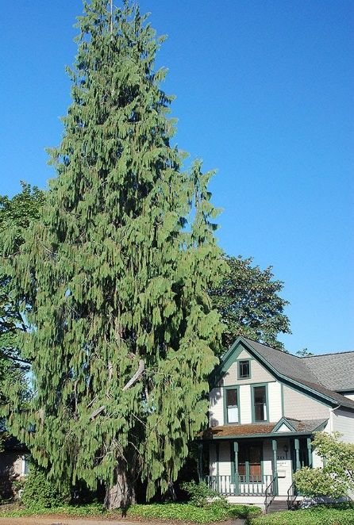
Small cones sit on top of the branch; look like tiny rose buds | Duck-bill shaped; when open, “tongue” sticking out | Small, round cones
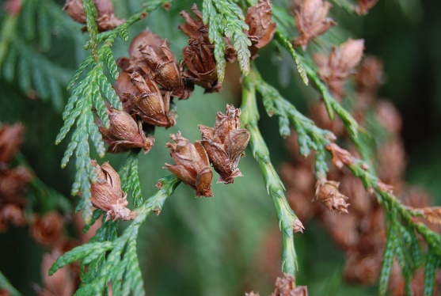 | 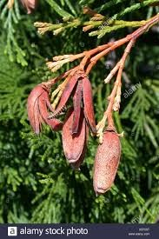 | 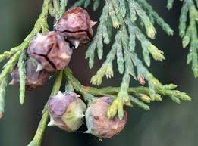
Stringy, reddish-brown bark; base of tree buttressed, with roots extending away from tree before reaching the ground | Reddish-brown bark, deeply furrowed on older trees | Like WRC, stringy bark, but more gray: strips wider & often detached i.e. “scruffy”
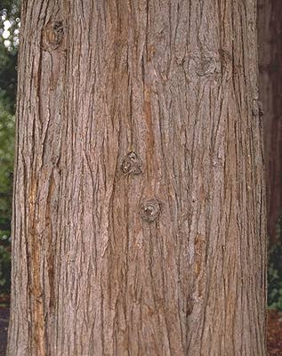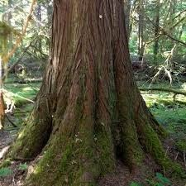 | 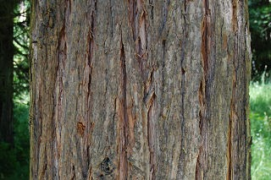  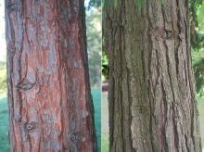 | 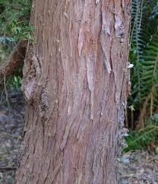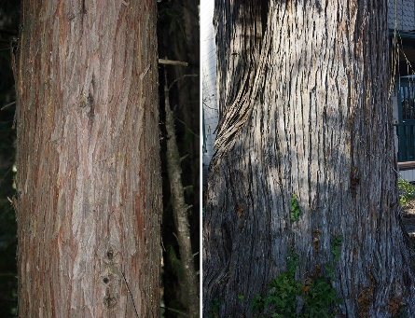
Minimal odor when crushed; some say pineapple-like | An aromatic odor when crushed | An unpleasant, mildewy odor when bruised
Check out: https://landscapeplants.oregonstate.edu/four-cedars-native-oregon

